**Practical No: 1**

**Aim: Configure IP SLA (On GNS3).**

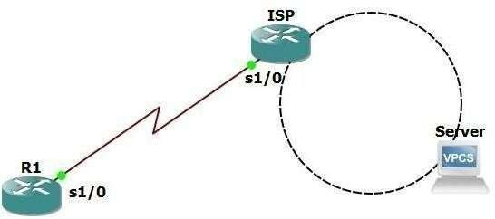

|  |  |  |  |
| --- | --- | --- | --- |
| **Device** | **Interface** | **IP address** | **Network Mask** |
| R1 | s1/0 | 209.165.200.9 | 255.255.255.252 |
| ISP | s1/0 | 209.165.200.10 | 255.255.255.252 |
| Lo 0 | 198.133.209.1 | 255.255.255.255 |

**Configure R1** R1#conf t R1(config)#int s1/0

R1(config-if)#ip add 209.165.200.9 255.255.255.252

R1(config-if)#no shut R1(config-if)#ip route

R1(config-if)#ip route 0.0.0.0 0.0.0.0 209.165.200.10 R1(config)#exit

**Configure ISP**

R2#conf t R2(config)#hostname ISP ISP(config)#int s1/0

ISP(config-if)#ip add 209.165.200.10 255.255.255.252

ISP(config-if)#clock rate 4032000 ISP(config-if)#exit ISP(config)#no ip domain-lookup ISP(config)#int loopback 0

ISP(config-if)#ip add 198.133.219.1 255.255.255.255

ISP(config-if)#no shut ISP(config-if)#exit ISP(config)#int s1/0 ISP(config-if)#no shut ISP(config-if)#exit

**Check connectivity on ISP server**

ISP#ping 198.133.219.1

**Check connectivity on R1 to ISP and server**

R1#ping 209.165.200.10

**Configure IP SLA on R1**

R1#conf t

R1(config)#ip sla 22

R1(config-ip-sla)#icmp-echo 198.133.219.1

R1(config-ip-sla-echo)#frequency 20

R1(config-ip-sla-echo)#ip sla schedule 22 start-time now life forever R1(config)#end

**Check IP SLA configuration**

R1#sh ip sla configuration

**Refresh ISP**

ISP # conf t

ISP # int loopack 0

ISP # shutdown

ISP # no shut

**Check IP SLA statistics**

R1# s hip sla statistics